1st GRADE SCHOOL SUPPLY LIST 2020-2021
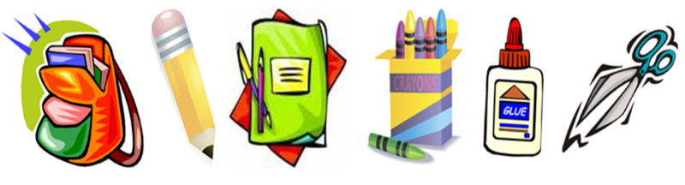
Please label each item with child’s name.
- 1 box of 24 crayons/coloring pencils (NO markers)
- #2 sharpened pencils
- 1 pencil pouch (NOT PENCIL BOX)
- 2 compositions notebooks (wide-ruled)
- 4* 2-pocket folders (red, blue, yellow, & green)
- 5 book covers
- 1 headphone for iPad
- 1 large box of facial tissues
- 1 Clorox wipes
- Masks
- Gloves
- Face shield
- 1 roll of paper towel
- 1 box Ziploc bag (sandwich size)

